COLUMBIA COLLEGE OF NURSING RESEARCH CELL - Ph.D. IN NURSING
IN COLLABORATION WITH RAJIV GANDHI UNIVERSITY OF HEALTH SCIENCES, KARNATAKA.
uGUIDELINES (PROSPECTUS) FOR Ph.D. NURSING PROSPECTIVES ASPIRANTS - 2023-2024 SESSION (EFFECTIVE FROM THE ACADEMIC YEAR 2023 TO 2024).
(Applicable for the Selected Students)
CONTACT OFFICER : Research Director, Ground Floor, Advanced Research Centre, COLUMBIA COLLEGE OF NURSING, Karnataka, 560056. India
Tel: +91…………….. , Email: ……………….., Web: www.columbiacollege.org

PhD in Nursing in India is a doctorate degree which deals in the field of Nursing for the betterment of Health care facilities. PhD Nursing is a research level program, where PhD Nursing course duration ranges from 3 to 5 years.
Upon completion of this research level program, students will be able to find employment as a Director of Nursing, Nurse Researcher, Rehabilitation Specialist, Critical Care Nurse, Nurse Manager, Community Health Specialist etc.
About PhD Nursing:
- This program helps students integrate knowledge, skills, and attitudes from the areas of management, clinical practice, and generic areas of Nursing, and this is a major reason why get a PhD in Nursing. The course falls under the umbrella of PhD.
Why Choose PhD Nursing?
- Students often wonder about PhD Nursing details before choosing the course. Before deciding on a career, students come across queries like, "What is a PhD Nursing course?" and "Why choose PhD Nursing?”. To clearly understand the answers to these questions, we have framed the following three pointers:
What is PhD Nursing All About?
- PhD Nursing courses in India is a three to five years full-time doctorate programme within the field of Nursing.
- This course contributes towards the development of knowledge and analytical skills of students and enhances their action and decision-making skills, which in turn provides them with a solid foundation for lifelong learning.
What Does a PhD Nursing Graduate Do?
- After completion of this course, students easily get jobs as a Chief Nursing Officer or Assistant Nursing Officer in numerous healthcare organizations or they can also choose to work as a Community Health Expert or Rehabilitation Specialist in a Rural/ Urban setting.
- With this program, aspirants will get a large number of opportunities to develop your own learning techniques through a series of educationally useful and challenging learning experiences

Reasons Why PhD Nursing Can Fetch You a Rewarding Career?
- There are a large number of benefits of PhD in Nursing courses. The completion of a PhD Nursing degree program is a notable achievement and is valued very highly both inside and outside of academia. Having a PhD Nursing degree opens thriving career opportunities.
Career Scope and Options:
- Successful professionals of this course are usually hired as Chief Nursing Officer, Rehabilitation Specialist, Critical Care Nurse, Nurse Manager, Community Health Specialist etc.
- Students can opt for jobs in numerous sectors such as Public Health Departments, Hospitals, Community Organizations, Wellness Centers, School Systems, Rural/ Urban Settings etc. on completion of this course.
Preparation Tips for PhD Nursing

Some Tips for Entrance Exams are:
- Get To Know The Syllabus: The syllabus of the course is something that a student should know, this helps the student to know how to perform at the time of the examination.
- Time Management: This is the most important aspect of one’s preparation, so students must pay attention to this. Aspirants are advised to make a proper timetable and follow the same strictly to boost their preparation and perform well in the entrance test.
- Practice Makes Perfect: Go through all the subjects and the modules that are taught in the duration of the course.

- Salary of a PhD Nursing Graduate: The salary of a PhD holder will differ with field and position. As a fresher, the average salary ranges around INR 7 - 7.5 LPA. It will increase up to INR 12 LPA, depending upon your skills and experience. This value is variable due to many factors like job designation and location.
- Career Options After PhD Nursing: There are a large number of job opportunities for Nurses qualified with a Nursing Degree. With a PhD degree in Nursing, students will be able to find jobs in the primary care, travel sector among several others. Here are some job positions available after PhD Nursing:
- Infection Control Nurse
- Nurse Manager
- Nursing Assistant Supervisor
- Junior Psychiatric Nurse
- Chief Nursing Officer
- Assistant Nursing Officer
- Critical Care Nurse

Skills That Make You The Best PhD Nursing Graduate:

Just like every profession, there are some skills that aspirants need to have in Nursing. Must have skills are:
- Analytical Thinking
- Critical Thinking
- Good Management Skills
- Good Organizational Skills
- Research and Problem Solving Skills
- Strategic Communication Skills

PHD REVISED ORDINANCE (RGUHS) MARCH 2023

REVISED ORDINANCE GOVERNING ENROLMENT OF CANDIDATES FOR RESEARCH LEADING TO Ph.D IN VARIOUS FACULTIES OF HEALTH SCIENCES -2023-2024

Rajiv Gandhi University of Health Sciences is also committed to promote research activities, both in basic and applied aspects in various faculties of Health Sciences such as Medical, Dental, Pharmacy, Indian System of Medicine including Homoeopathy, Nursing, Physiotherapy and other allied Health Sciences in the institutions/colleges affiliated to this University.

LIST OF CONTENTS

Sl No |  | Page No
1. | Notification
2. | Eligibility Criteria for Entrance Examination
3. | Eligibility Criteria For Admission To Ph. D. Programme
4. | Syllabus for Entrance Examination.
5. | Duration Of The Ph.D. Programme
6. | Procedure for Admission
7. | Eligibility criteria Research Guide/ Co-Guide
8. | Permissible number of PhD scholars per Guide and per Department
9. | Ph.D Registration Committee
10. | Submission of Half Yearly Progress Reports and Evaluation of Course Work
11. | Pre PhD Exam
12. | Submission of final synopsis
13. | Publication of research papers
14. | Plagiarism
15. | Submission and Evaluation of Thesis
16. | Recognition of Institution/College as Centers for Ph. D Studies
17. | Depository with Library

Ph. D Entrance Exam – 2023-24
TENTATIVE CALENDAR OF EVENTS
Sl No | Events | DATES
1. | Date of Notification | 10/03/2023
2. | Hosting of the Brochure and Application form on the website | 14/03/2023
3. | Last date for online Payment | 12/04/2023  Before 05.00 P.M
4. | Last date for receipt of print-out of applications filled online by Post or In person before 5-00 P.M at RGUHS. | 21/04/2023
5. | Date of availability of Hall-Ticket for the  Eligible candidates | 29/04/2023
6. | Date of Entrance Exam | 04/05/2023
7. | Provisional Result | Second week of June - 2023
8. | Submission of preliminary Synopsis by qualified candidates | Second week of July - 2023
9. | Presentation of Synopsis before the Committee | Third week of August- 2023
10. | Commencement of Session | September - 2023

NOTIFICATIONS

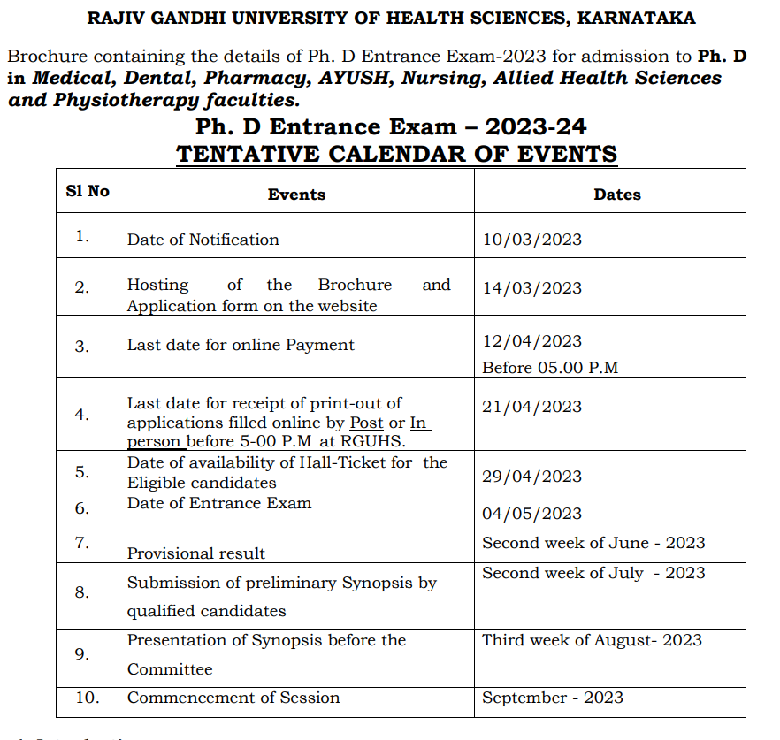

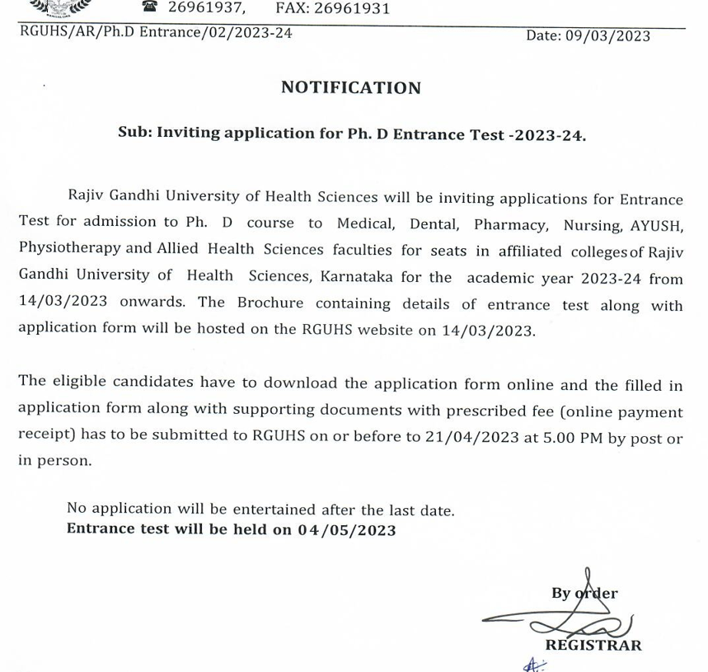

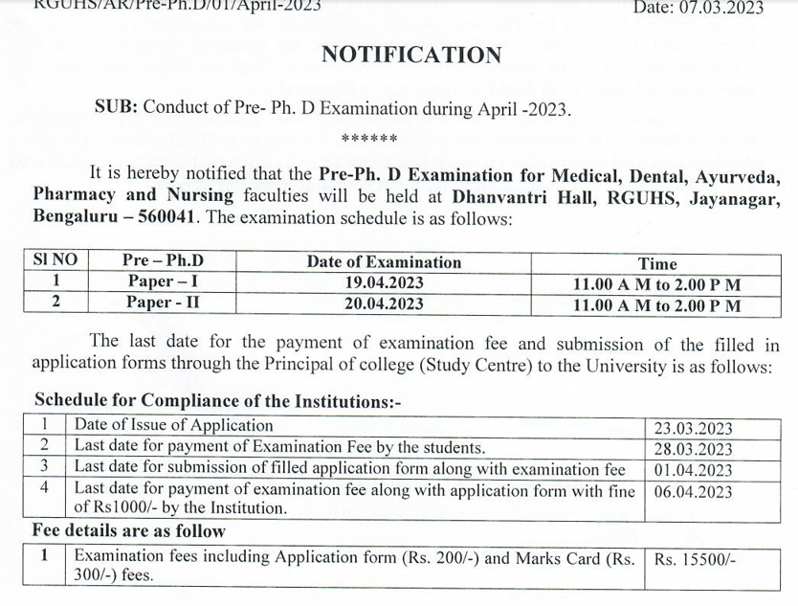

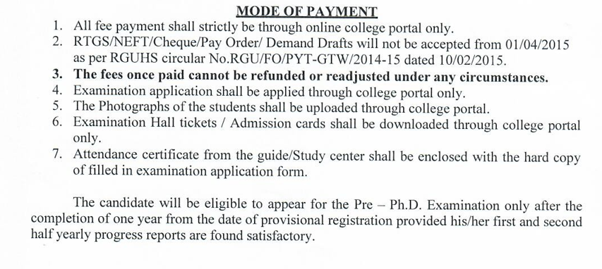

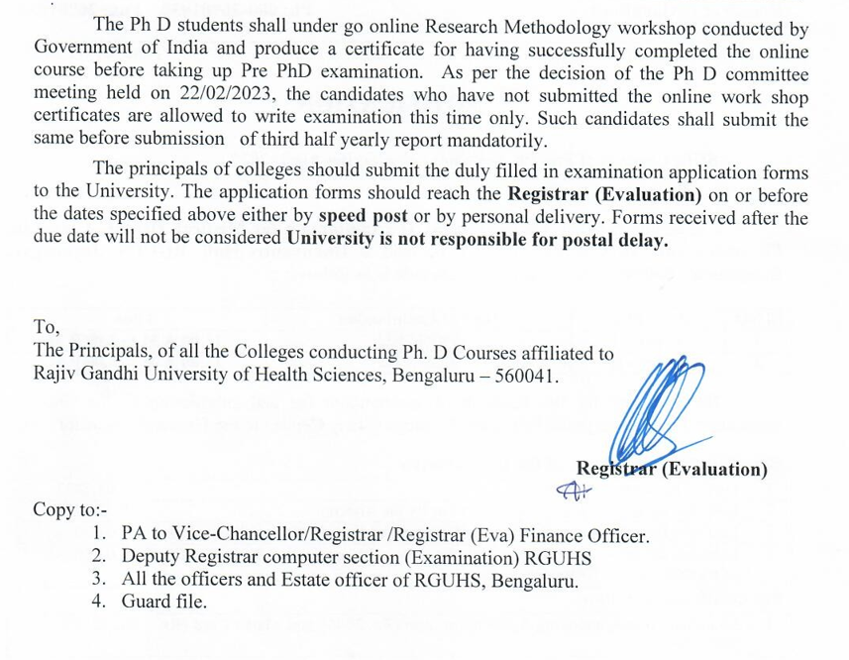

ELIGIBILTIY CRITERIA :

ELIGIBILITY CRITERIA TO APPEAR FOR ENTRANCE EXAMINATION:
A Post Graduate qualification in the concerned specialization and faculty.
ELIGIBILITY CRITERIA FOR ADMISSION TO Ph. D. PROGRAMME:
The Students who secure 50th percentile and above in the Ph D Entrance Examination are declared selected for admission to Ph D courses as per calendar of events and such result is valid for two terms (for that academic year and next academic year) subject to availability of guides.
Eligibility (Nursing):

- Candidates with M.Sc/M.Phil in Nursing degree awarded by this University or a College/University Recognized by INC
or
- P.G. Degree in Nursing considered as equivalent by INC are eligible for enrollment for Ph.D course in concerned subjects of Nursing.

NOTE : NRI…
- Foreign Nationals / NRIs intending to register for Ph.D Programme should obtain equivalence certificate from AIU and Eligibility Certificate from RGUHS before admission.
- The post graduate qualified Candidates from other Universities applying for Ph.D Registration are required to obtain eligibility certificate by paying the eligibility fees as prescribed for PG Program by RGUHS.
- All foreign nationals irrespective of their PG Studies in India (including RGUHS) or abroad are required to obtain eligibility certificate by paying eligibility fees and submission of copies of valid passport, visa and police permission for residential permit for stay in India.
- The M.Sc degree holders, after their Ph.D shall confine themselves only to provide research inputs and perform investigative procedures. They are not permitted to treat patients but they can involve in academic work.
SYLLABUS FOR ENTRANCE EXAMINATION:The Entrance Exam Is Conducted In Two Parts Namely

1. Principles of Basic Research Methodology : Paper - I
2. Speciality Paper : Paper – II
The specialty paper Syllabus content shall ordinarily be equal to the Syllabus and Books prescribed for Post-Graduate Course for that subject as per Regulations of Indian Nursing Council and/ or the Rajiv Gandhi Universities of Health Sciences.
The Principles of Basic Research Methodology Syllabus is as follows:
(1) Research Methodology: An Introduction
(2) Defining the Research Problem, Hypothesis, Generation of Hypothesis
(3) Research Design
(4) Sampling Design
(5) Measurement and Scaling Techniques
(6) Methods of Data Collection

(7) Processing, Statistics and Analysis of Data
(8) Sampling Fundamentals
(9) Interpretation and Report Writing
(10) Principles and Methods of fundamental research method, literature, drug and research problem survey, clinical research
(11) Writing an article for a scientific journals
(12) Bioavailability
(13) Bioequivalence
(14) Clinical Trials.

4.1 Duration, Nature of Question Paper and Answer Booklet:

There are separate papers for

- SPECIALTY SUBJECT - with 50 marks and
- BASIC RESEARCH METHODOLOGY paper - with 50 marks.
- Paper - I Question paper comprises of 8 Questions of 10 Marks each.
- Paper - II Question paper comprises of 8 Questions of 10 Marks each.
- The candidate shall answer ANY FIVE QUESTIONS out of Eight Questions in both the papers.
- Duration of examination is THREE HOURS AND SEPARATE ANSWER BOOKLETS are issued for each paper.

5. DURATION OF THE Ph.D. PROGRAMME:

5.2 Where the candidate, Ph. D guide and the Research Department are in the Same Institution, the course duration for full time course is Three years and for part time course it is Four Years for all Faculty except those under 4.1.
5.3 Where the guide and research department are from one institution and the candidate is from another institution affiliated to RGUHS, the minimum course duration for Part time Ph.D. shall be for five years.
The registration of candidates for Ph.D will not be considered, if the candidate, guide and research department are in three different places.
5.4 The Ph.D. programme in all other subjects except those cited at 4.1 above shall be for a minimum duration of three years for full time course and five year for part time course.
Maximum duration shall be seven years including course work from the date of his/her provisional registration for all other faculty.

5.5: Extension beyond the above limits may be considered by the Ph.D. Registration committee of the respective faculty on case to case basis.
Only in exceptional cases, the maximum duration can be extended for one more year based on the representation submitted by the student and the guide. This provision can be applied only with the approval of the Hon’ ble Vice Chancellor.
5.6: The candidates with more than 40% disability may be allowed a relaxation of two years for Ph.D. in the maximum duration.

5.7: The women candidates may be provided Maternity Leave/Child Care Leave once in the entire duration of Ph.D. for up to 240 days. However, during the course of Ph D Period candidates has to make up for this lost period by working for equivalent additional period.
Note:
In case of relocation of a Ph.D. scholar due to marriage or otherwise, the research data shall be allowed to be transferred to the University to which the scholar intends to relocate, with prior consent of the Guide provided all the other conditions in these regulations are followed in letter and spirit and the research work does not pertain to the project secured by the parent institution/Guide from any funding agency.
The scholar will however give due credit to the parent guide and the institution for the part of research already done.

This relocation should be done with the approval of the Ph.D. Registration committee of the respective faculty and approval of Hon’ble Vice Chancellor.

- The contact period for Part time Ph.D Student shall be 45 days for every 6 months.
- The candidate has to submit attendance certificate duly signed by the Guide and the Principal for this period through proper Channel along with half yearly reports.
- 5.9: Part Time facility provided for pursuing Ph.D Programme can be availed ONLY by teaching faculty working in colleges affiliated to RGUHS and eligible candidates working in department of different Institutions/Industry/Hospitals recognized by RGUHS as Ph.D research centers.
- Foreign nationals are eligible for only full time Ph D course.
- Such of the faculty from outside the state/University who wishes to apply for Ph D course can apply only for full time Ph D course.

6. PROCEDURE FOR ADMISSION:

6.1 All the candidate intending to register for Ph.D. program shall appear for the entrance test conducted by the University.
6.1a. An Entrance Test shall be qualifying test with qualifying marks as 50th Percentile.
Percentile method be adopted for declaration of the result.
The University reserves the right to lower this percentile limit, in case the number of candidates who have cleared Ph D entrance examination is very low. This shall be given effect to with the approval of the Hon,ble Vice Chancellor.
The test consists of two papers, conducted over two sessions of three hours.
The syllabus of the first theory paper consists of Basics of Research Methodology and will carry 50 marks.(10X5)
The Second theory paper which will be subject specific, preferably with the competence of PG standard, will carry 50marks.(10X5)
There shall be eight questions with each questions carrying ten marks.
The candidate shall answer any five questions out of eight questions in both the papers.

PASS CRITERIA:

- The marks scored by the candidate for BOTH THE PAPERS PUT TOGETHER be considered for deciding the pass criteria.
- Percentile method is adopted for declaration of the results.
- Faculty wise 50th PERCENTILE shall be cut off point to declare for having passed Ph D entrance examination.
- If multiple candidates score equal marks in entrance examination, ranking will be based on marks scored in Post Graduation examination.
- In case, the Post Graduation marks are also same, then Under Graduate marks will be considered.
- If the Under Graduate marks are also same, then candidate who is senior in age will be considered for higher ranking.

6.1b. An interview/viva-voce to be organized by the University for the candidates who successfully clear the entrance test and are selected for the Ph.D. course to discuss their research interest/area through a presentation before a duly constituted University Ph.D. Registration committee of the respective faculty.

6.1c. The interview/viva voce will also consider following aspects, viz. whether:
i. To evaluate the research aptitude of the applicants.
ii. The candidate possesses the competence for the proposed research.
iii. The research work can be suitably under taken at the Institution/College.
iv. The proposed area of research can contribute to new/additional knowledge.

6.2 There will be only one stream of admission annually. The eligibility secured at the entrance test is valid for admission as per calendar of events and such marks are valid for two terms (for that academic year and next academic year).
6.3. The Colleges under the university which are allowed
to conduct Ph.D. programmes shall decide on an annual basis through their academic bodies, a predetermined and manageable number of Ph.D. scholars to be admitted,
depending on the number of available Research Guides (not exceeding the permissible number of Scholars in each department)and other academic and physical facilities available.
They shall follow the norms regarding the scholar- guide ratio, laboratory, library and such other facilities as prescribed by the University.
6.4. The University will notify well in advance through the University website regarding the criteria for admission, procedure for admission, details of entrance test center(s)and all other relevant information for the benefit of the candidates.
6.5. The University shall maintain the list of all the Ph.D. registered students on its website on year-wise basis. The list shall include the name of the registered candidate, topic of his/her research, name of his/ her Guide/co-Guide and date of enrolment/registration.

ELIGIBILITY CRITERIA FOR RESEARCH GUIDE /
CO-GUIDE:
ELIGIBILITY CRITERIA FOR RESEARCH GUIDE /
CO-GUIDE:

Eligibility criteria required for a Research Guide/Co-Guide are as follows.
- Only Teaching/Research faculty working fulltime in the Institutions/Colleges affiliated to RGUHS can act as a Guide. The external Guides are not allowed.
- The Co-Guide from other departments of the same institute or from other related institutions can be allowed in related inter-disciplinary research activities with the approval of the Ph.D. Registration committee of the respective faculty.
- The maximum age to guide Ph D student shall be as per Apex body guidelines. It has to be noted that the candidate must complete his/her thesis work before the stipulated retirement of Ph D guide as per Apex body regulations.
- In case of Government Institutions where superannuation is fixed at 60 years, the guide should not have completed 55/57 years of age at the time of registration of the candidate for part time/full time Ph.D course under him/her provided the guide continues to work as a full time teacher in the Institutions /Colleges affiliated with the RGUHS.
- Similarly, in all other faculties (Nursing, Pharmacy, AYUSH) as per the Apex Body norms, the guide should not have completed 60/62 years of age for guiding part time/full time Ph D students respectively.

- In above circumstances, the concerned college shall give an affidavit stating that the Ph D guide will be continued in that college till the completion of the Ph D by the concerned Ph D student.
- In case the student is not in a position to complete the work prior to the guide’s retirement, it is the duty of the guide to hand over the candidate to another recognized guide from the department after obtaining prior permission from the University
- OR get an extension letter from the Dean/Principal of the current Institution stating that the Guide continues to be full time teacher even after retirement until the student submits the thesis to the University.
- A Recognized Guide desirous of pursuing Ph.D. shall not be permitted to continue as Member of Ph.D committee of RGUHS and similarly, no Ph.D. Research scholar shall be appointed as RGUHS Ph.D committee member.
- With the consent of current Registered Guide, any request for Change of Guide may be permitted

8. PERMISSIBLE NUMBER OF Ph D SCHOLARS PER GUIDE AND PER DEPARTMENT

a) The maximum number of Full time or part time candidates a guide can supervise shall not exceed Six (6) at any given time.
- Whenever the number of candidates registered under a Guide has reached the maximum,
a Guide becomes eligible to supervise another Ph.D. candidate only after the submission of the thesis by any one of the Ph.D. candidates already registered under him/her.
Any ambiguity in this regards will be addressed by the Ph. D Registration committee of that faculty.
c) Recognized Ph.D. department at any given point of time can have only Ten (10) Ph.D. scholars in all faculties.
d) A candidate may have one Co-Guide from another department, duly recognized by the Ph.D Registration Committee of the University in addition to the Guide from the concerned specialty.
e) All Guides shall normally be residents within the jurisdiction of Research centre and should be the recognized by the University as Ph.D. Guides based on their commendation of the Ph.D Registration Committee of the respective faculty.
f) Guide recognized by the University is not eligible to Guide any other Ph.D students from any other University.

9. Ph.D REGISTRATION COMMITTEE SHALL CONSIST OF:

a. Dean of the respective Faculty - Chairman
b. BOS Chairman PG Studies - Member
c. Past Dean - Special Invitee
d. Two Senior Faculty - Members
e. Two Subject Experts - Special Invitee
f. Director Advanced Research - Member Secretary

10. SUBMISSION OF HALF YEARLY PROGRESS REPORTS AND EVALUATION OF COURSE WORK:
- After PROVISIONAL REGISTRATION,
every candidate shall submit the half yearly progress reports regularly as desired by the university in the prescribed format through the Guide to the Registrar of the University with a copy to the Head of the Department concerned and Head of the Institution.
The half yearly progress report will be assessed by the subject experts and comments/observations will be communicated to the concerned candidate and Guide.
Every such half yearly report shall be submitted once in six months from the commencement of term.
The accepted reports shall be ratified by the Ph.D registration Committee.
- b) All Ph. D. candidates while submitting their current progress report should submit the summary of each of his/her previous half yearly progress reports in order and suggestions made by the previous reviewers along with university letters sent to the candidates for approval of the current report.
- All Ph. D. candidates should submit their half yearly progress reports in the prescribed format issued by the University.
- In case the progress of the research scholar is unsatisfactory, the Ph. D. Registration committee of the respective faculty shall record the reasons for the same and suggest corrective measures.
- All the Ph. D. students should maintain a Logbook, duly signed by the Guide & Head of the department/Institution and should be made available at time of inspection and examination.
- c) The Research project submitted by the candidates should have been cleared by the appropriately constituted Institutional Ethics Committee at college level (respectively for experiments on human subjects and / or animals) before the submission of the 1st progress report by the candidates.
- d) If two consecutive half yearly progress reports are not satisfactory, the Ph.D. Registration committee of the respective faculty may recommend to the University for Cancellation of the registration of the respective candidate.

11. PRE - Ph. D EXAM:

- Pre Ph D examination shall ordinarily be completed at the end of one year after submission and satisfactory clearance of two half yearly reports.
If for some reason, the two half yearly reports are not submitted within due date, Ph. D registration committee has the right to conduct Pre Ph D examination within the next six months.
If the candidate fails to take up his/her pre Ph D examination within two years from the time of his registration of his Ph D, he shall be discharged from the course.
B) Ph D students shall under go online Research Methodology workshop conducted by Government of India and produce a certificate for having successfully completed.

SCHEME FOR PRE PHD EXAMINATION:

The scheme for Pre Ph.D examination to be conducted by the University shall be as follows:
a) Two written papers each of three hours duration and each carrying maximum of 100 marks.
- PAPER I: Research Methodology related to the area of research.
- PAPER II: Topics related to the specialized subject under which the topic / area of research is undertaken.
b) A Viva-Voce examination carrying a maximum of 100 marks for candidates who have passed the theory examination.
The Syllabi for both papers for each candidate shall be prescribed by the concerned Guide which will be communicated to the Registrar (Evaluation) of the University as well as the candidate at least one month earlier to the examination.

c) Conduct of Pre Ph.D Examination:

- The Ph.D Registration Committee along with the names suggested by the concerned Guides shall prepare an exhaustive panel of both external and internal examiners and recommend the same to the Vice Chancellor and Registrar (E) for approval.
The University / Registrar (E) will then constitute a Board of Examiners for conduct of the Pre Ph.D Examination.
ii. The Board of Examiners for the Pre Ph.D Examination (theory) consists of the following:
1. Internal Examiner (other than the guide). to be chosen by the University.
- One external examiner chosen by the University.
Note: The examiner shall fulfill the criteria for eligibility similar to Ph.D Guides as per RGUHS Ordinance.

- The Internal Examiner and External Examiner chosen by the Registrar (E) from the panel of examiner will set two papers each and send their respective question papers separately in a sealed cover to the Registrar (Evaluation) who will conduct the theory examination and send the answer scripts to the examiners for valuation.
iv. There shall be double valuation of the answer scripts of Paper-I and Paper II by the same examiners who have set the question papers.
The marks lists shall be sent by the examiners directly to the Registrar (Evaluation).

- If the Difference of the marks in the valuation between the external and the internal examiner exceeds 15%, the concerned answer scripts will be evaluated by a third Examiner.
- The candidate should secure a minimum of 60% marks in each of the written papers to pass the Examination.
vii. The viva voce examination shall be conducted after the candidates has passed in the theory papers by a Panel consisting of:

1) Internal Examiner ( Guide)
2) External Examiner (any one of the two examiners who have set the theory papers and valued the answer scripts).
viii. After the Viva-Voce examination, the marks shall be consolidated and sent to the Registrar (Evaluation) by the Chairman for further consolidation and announcement of results.
ix. The Results will be announced according to the Following Grading System.

DECLARATION OF RESULTS (Pre -Ph.D Examination)

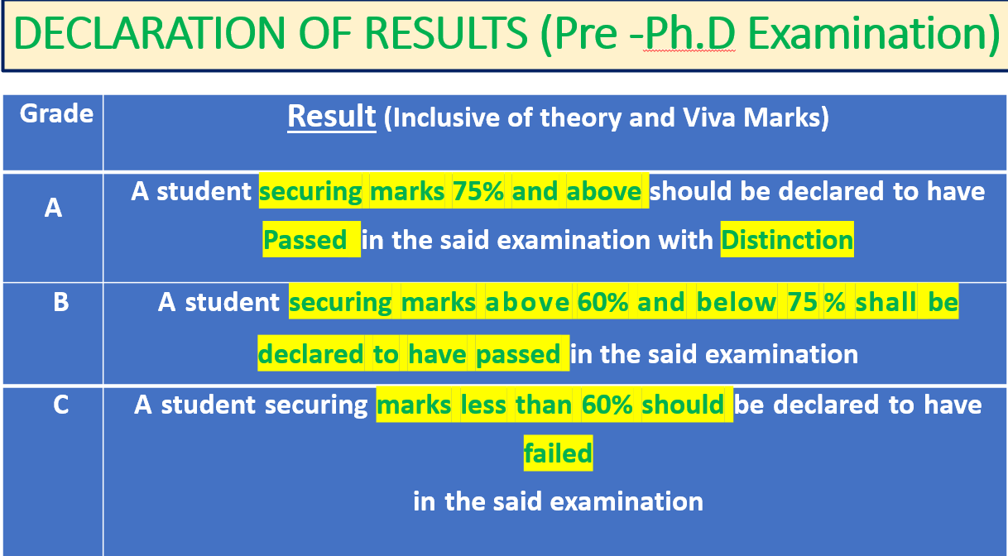

- However, the candidate should secure a minimum of 60% marks in each of the written papers as well as in the Viva-Voce examination.
- In case the candidate is not successful in the Pre Ph.D Examination in the first attempt he/she may be given one more chance to appear for the entire examination after a period of six months.
- If the candidate is not successful in the Pre Ph.D examination, even in the second appearance, his/her provisional registration shall stands cancelled.
- Provisional registration of the candidates will be confirmed only after they pass the Pre Ph.D examination.
- Pre Ph D examination shall be conducted by Examination section of RGUHS.

12. EVALUATION AND ASSESSMENT:

SUBMISSION OF FINAL SYNOPSIS
All the Ph.D candidates should submit a final synopsis containing the summary of the research work done (Two Soft & Hard Copies) to RGUHS before submission of thesis. All Ph.D candidates before submitting their final synopsis shall present his/her research work before the Guide, External Examiner and Observer from concerned specialty on a suitable date fixed by the University and should get approval for writing the final synopsis and thesis.
PUBLICATION OF RESEARCH PAPERS
All Ph. D. Candidates before submitting Ph.D. Thesis to the university should have published a minimum of four research papers related to their research topic during their course of Ph. D as 1st author or corresponding author in the indexed journals. One of the publications shall be published in RGUHS journals. These publications shall be verified by the department of Library, RGUHS.

12.3. PLAGIARISM check:

- The Academic Council (or its equivalent body) of the Institution shall evolve a mechanism using well developed software and gadgets to detect plagiarism and other forms of academic dishonesty.
While Submitting For Evaluation,
- the thesis shall have an Undertaking from the Research Scholar
- and a Certificate from the Research Guide attesting to the originality of the work, vouching that there is No Plagiarism (the permissible similarity should not exceed 15% of total contents) and
- that the work has not been submitted for the award of any other degree/diploma of the same Institution where the work was carried out, or to any other Institution.
- It is Mandatory For Plagiarism Check for Ph.D thesis submitted before sending it for evaluation.
- The Report Of Plagiarism check shall be Enclosed.

Submission and Evaluation of Thesis :

- Each candidate for the Award of Ph.D Degree shall submit three copies (Soft & Hard Copies) of his/her Thesis not earlier than the prescribed minimum period and not later than the prescribed maximum period.
- The Ph.D. thesis submitted by a research scholar shall be evaluated by at least two external examiners (who are not teachers of the Institutions affiliated to RGUHS) of whom one examiner may be from outside the country.
- The VIVA-VOCE Examination, based among other things, on the critiques given in the evaluation report, shall be conducted by the Research Guide and at least one of the two external examiners, and shall be open to be attended by Members of the Ph.D Committee, all faculty members of the Department, other research scholars and other interested experts/researchers.
- Based on the reports of the examiners, the University shall Award the Ph.D Degree after the recommendations are approved.

FEE STRUCTURE:

- The fee structure could be similar as per the Existing Fee Structure for the Ph D programme in the teaching institutions.
(Vide University notification No. ACA/ORD-23/97-98 (Part II) dated 07.07.2005. Institutions/Colleges desirous of seeking recognition of their Departments by the University as Ph.D study centers may contact the Affiliation section of the University for obtaining the application form on payment of the prescribe fee.
- All PhD study centers both teaching and non-teaching institutions Shall Seek Renewal Of Recognition Every Three Years On Payment Of Prescribed Fees.

DEPOSITORY WITH LIBRARY :

- Following the Successful Completion Of The Evaluation Process and before the announcement of the award of the Ph.D. degree(s), the Institution concerned shall Submit An Electronic Copy Of Ph.D Thesis to the RGUHS Library for hosting the same in RGUHS website so as to make it accessible to all Institutions / Colleges.
- Prior to actual award of the degree, the degree awarding Institution shall issue a provision Certificate to the effect that the Degree has been awarded in accordance with the provisions of these UGC Regulations, 2016.

*******************
……………………………………………………………………………………………………………………………………………………………………………………………..

RECOGNITION OF INSTITUTION/COLLEGE AS CENTRES FOR Ph. D STUDIES The Academic, administrative and infrastructure

A requirement to be fulfilled by Colleges for getting recognition for offering Ph. D. programmes are as follows:
A candidate shall be permitted to pursue research activities for the degree of Doctor of Philosophy (Ph. D) in any one of the following institutions:
a. Departments run by RGUHS
b. Post Graduate Departments of Colleges/Institutions affiliated to RGUHS :-
1. Recognized as having necessary infrastructure and facilities such as exclusive research laboratories with sophisticated equipment, provision for adequate space per research scholar along with computer facilities and essential software, and uninterrupted power and water supply for carrying out research in the subject of study concerned.
2. Provided that the department has at least one qualified Guide.
3. Offering the Postgraduate course for a minimum period of five years in concerned subject.
4. The Post Graduate Department of the said colleges should have been approved by University as a recognized Ph.D center.
5. Colleges may also access the required facilities of the neighboring Institutions/ Colleges, or of those Institutions/Colleges/R&D laboratories / Organizations which have the required facilities through an MoU.

c. Any other non-teaching research institution duly recognized by this University for conducting research leading to the award of Ph. D degree on the recommendations of an expert committee appointed by the Syndicate.
Any non-teaching institutions seeking recognition for Ph. D programmes:
1) Should be a center of academic excellence and repute or Institute of National Importance.
2) Should have been actively functioning and should have been in existence for at least 5 years.
3) Should be a centre of research activity as evidenced by ongoing research projects funded/ sponsored by reputed agencies like ICMR, AICTE, DST, UGC etc.,
4) Should have published Five research papers in the peer reviewed scientific journals or indexed journals.
5) Should have specifically equipped research labs with the requisite infrastructure and facilities for the proposed Ph. D programme.
6) The Department which proposes to start the Ph. D programme in the institution should have at least three staff members with required PG qualification in the concerned specialty and a total of 10 years Post Graduate teaching or research experience.

